ASSIGMENT #4

Q#1 Part e

#include<iostream>

using namespace std;

int main()

{

int size;

int i, j;

cout << "Enter size : ";

cin >> size;

int size2 = (size + 1) / 2;

for (i = 1; i <= size; i++)

{

for (j = 1; j <= size; j++)

{

if (j == size2 || i == size2)

cout << "\*";

else

cout << " ";

}

cout << endl;

}

}

Output

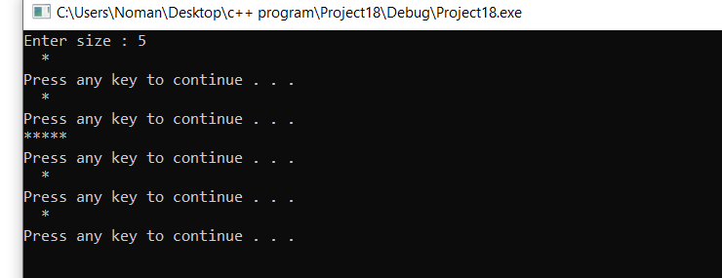

Q#1 PART(c)

#include<iostream>

using namespace std;

int main()

{

int size;

int i, j, k;

cout << "Enter size ";

cin >> size;

int num = 97;

for (i = 0; i < size; i++)

{

for (j = size - 1; j >= i; j--)

{

cout << " ";

}

num = 97;

for (k = i; k >= -i; k--)

{

cout << char(num);

num++;

}cout << endl;

}

system("pause");

}

OUTPUT

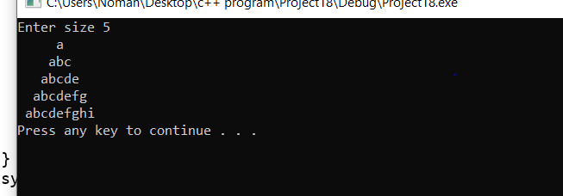

QUESTION #2

#include<iostream>

using namespace std;

#include<fstream>

int main()

{

int cocacola = 0, dew = 0, mirinda = 0, sprite = 0;

int choice;

int NoOfParticipants = 0;

bool flag = true;

while (flag)

{

cout << "choose your favourite drink(s) from the following menu : " << endl << "1 for CocaCola " << endl << "2 for Dew " << endl << "3 for Mirinda " << endl << "4 for Spirite " << endl << "5 to exit the survey " << endl;

cin >> choice;

if (choice != 5)

NoOfParticipants++;

if (choice != 0)

{

switch (choice)

{

case 1:

cocacola++;

break;

case 2:

dew++;

break;

case 3:

mirinda++;

break;

case 4:

sprite++;

break;

default:

flag = false;

3 }

}

}

//--------------a----------a------------a-----------a----------------

cout << "No of participants that are participate in the survey : " << NoOfParticipants << endl;

cout << "Coca cola: " << cocacola << "\t";

for (int i = 0; i < cocacola; i++)

cout << "\*";

cout << endl;

cout << "Dew : " << dew << "\t";

for (int i = 0; i < dew; i++)

cout << "\*";

cout << endl;

cout << "Mirinda: " << mirinda << "\t";

for (int i = 0; i < mirinda; i++)

cout << "\*";

cout << endl;

cout << "sprite: " << sprite << "\t";

for (int i = 0; i < sprite; i++)

cout << "\*";

cout << endl;

//------------filling for a ---------------

ofstream write;

write.open("surveyResults1.txt");

write << "No of participants that are participate in the survey : " << NoOfParticipants << endl;

write << "Coca cola: " << cocacola << "\t";

for (int i = 0; i < cocacola; i++)

write << "\*";

write << endl;

write << "Dew: " << dew << " \t";

for (int i = 0; i < dew; i++)

write << "\*";

write << endl;

write << "Mirinda: " << mirinda << "\t";

for (int i = 0; i < mirinda; i++)

write << "\*";

write << endl;

write << "sprite: " << sprite << "\t";

for (int i = 0; i < sprite; i++)

write << "\*";

write << endl;

write.close();

////------------b------------b--------------b------------b---------------and fillig-------------------------

write.open("surveyResults1.txt", ios::app);

write << "Coca cola\tDew\tMirinda\tSprite" << endl;

cout << "No of participants that are participate in the survey : " << NoOfParticipants << endl;

cout << "Coca cola\tDew\tMirinda\tSprite" << endl;

write << "No of participants that are participate in the survey : " << NoOfParticipants << endl;

write << "Coca cola\tDew\tMirinda\tSprite" << endl;

while (cocacola != 0 || dew != 0 || mirinda != 0 || sprite != 0)

{

if (cocacola != 0)

{

cout << "\*\t\t";

write << "\*\t\t";

cocacola--;

}

else if (cocacola == 0)

{

cout << "\t";

write << "\t";

}

if (dew != 0)

{

cout << "\*\t";

write << "\*\t";

dew--;

}

else if (dew == 0)

cout << "\t";

write << "\t";

if (mirinda != 0)

{

cout << "\*\t";

write << "\*\t";

mirinda--;

}

else if (mirinda == 0)

cout << "\t";

write << "\t";

if (sprite != 0)

{

cout << "\*" << endl;

write << "\*" << endl;

sprite--;

}

else if (sprite == 0)

cout << endl;

write << endl;

}

system("pause");

return 0;

}

OUTPUT

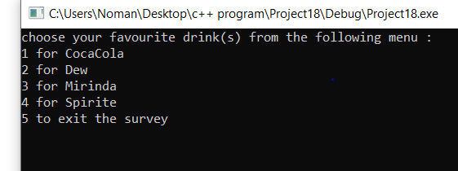

QUESTION #3

#include<iostream>

#include<string.h>

using namespace std;

int main()

{

string array[100];

int num, num2, factorial, factorial2;

cout << "Enter number : ";

cin >> num;

num2 = 1;

num2 = num - num2;

factorial = num \* num2;

factorial2 = factorial;

if (num > 0)

{

while (num2 > 0)

{

num2--;

if (num2 == 0)

{

break;

}

factorial = factorial2 \* num2;

factorial2 = factorial;

}

}

int num3 = factorial;

int count = 0;

int temp;

do

{

temp = num3 % 10;

num3 = num3 / 10;

if (temp == 0)

{

count++;

}

} while (temp == 0);

cout << "Number of zeros in factorial of " << num << " are : " << count << endl;

system("pause");

return 0;

}

OUTPUT

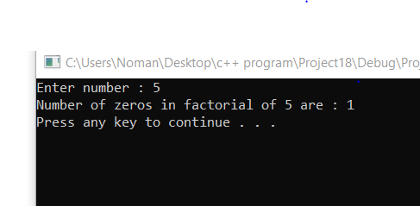

QUESTION #5

#include<iostream>

#include<fstream>

using namespace std;

int main()

{

char Newcharacter;

char replaced;

int replaced1;

char named;

int named1;

int count = 0;

cout << "Enter the character which you want to replace : ";

cin >> replaced;

replaced1 = int(replaced);

cout << "Enter New character : ";

cin >> Newcharacter;

ifstream read;

read.open("C:\\Users\\User\\Desktop\\AssignmentNo4\\program no 5\\text.txt", ios::app);

while (!(read.eof()))

{

read.get(named);

named1 = int(named);

if (named1 == replaced1)

{

cout << Newcharacter;

count++;

}

else if (named1 != replaced1)

if (!(read.eof()))

{

cout << named;

}

}

cout << "\noriginal character is : " << replaced;

cout << "\nreplaced with : " << Newcharacter;

cout << "\nNumber of replacements : " << count;

system("pause");

}

Output

